Box Elder Middle School

Student Planning Guide

Counseling office: (435) 734-4884
This Student Planning Guidebook has been created to help students plan for high school, graduation, college, career, and beyond. For questions, call (435) 734-4884 Monday through Friday from 7:30 a.m. to 3:00 p.m. to speak to your counselor, who is matched by the first letter of the student’s last name.

Amber Clark | A to G | amber.clark@besd.net
Jenni Bair | H to O | jennifer.bair@besd.net
Jordan Hansen | P to Z | jordan.hansen@besd.net
Tori Haderlie | Guidance Clerk | tori.haderlie@besd.net
Brandy Davies | Registrar | brandy.davies@besd.net

Box Elder Middle School
18 E 500 E
Brigham City, UT 84302
Top 5 Reasons to Go to College  1. A better paying job -- On average college graduates earn as much as 65% more than high school graduates. Most students want the best paying job they can get.  2. A more secure future -- Statistics show that people with higher levels of education and advanced training tend to have better job security and stay ahead of unemployment curves.  3. Respect -- Going to college and earning a certificate, a diploma, or a degree will help you feel better about yourself and also help you gain more responsibility and get promotions at work.  4. More choices – Most jobs today require specialized training that you can only get in college. That means you will need 1, 2, 4, or more years of education/training after high school to be prepared for jobs in your future.  5. Be the first! Are you hesitant because no one in your family has gone to college? Start a tradition! Education and training in college can have a positive impact on you and your entire family. |  | 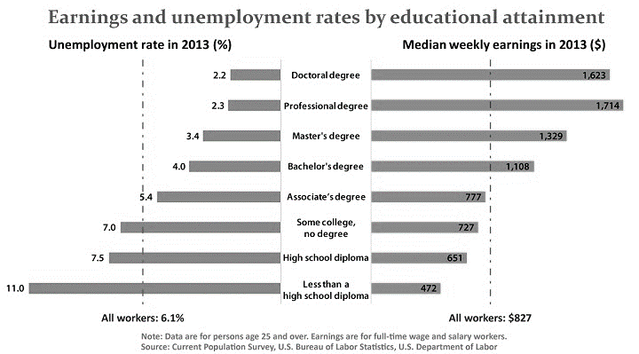  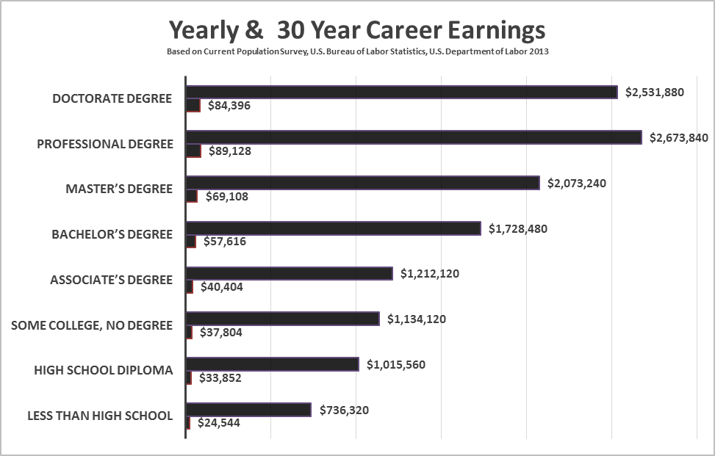

BEHS Graduation

Academic Requirements
- 30 Total Credits are required for a BEHS Diploma. These credits include 19.5 total core requirements and 10.5 elective credit requirements (see the graduation requirements table).
- All students will earn one (1) credit in a SAGE tested biological science class & (1) credit in another SAGE tested science class (Earth Systems, Chemistry, or Physics).
- All students must pass the basic civics test (see the American Civics Education Initiative, S.B.60, Utah Legislative Session 2015.) The civics test is untimed and can be repeated. The test is available on the student grade portal through the student passport login. A score of 70% is required. Proof of test completion will be recorded on the student grade portal. Additional information and test preparation materials can be found at: http://www.uen.org/american-civics-education/
- All students will earn one (1) credit in an approved science or math class, and (1) credit in a language class, in the three trimesters immediately prior to graduation.
- Students qualify for a diploma upon completion of all required credits. The opportunity to participate in graduation exercises may be based on attendance, enrollment, and citizenship.

Citizenship Requirement
Students must make up unsatisfactory citizenship marks (U’s) in order to participate in the graduation ceremony.

Pass/Fail Credits
Courses awarded a Pass (P) grade will not impact a student’s grade point average, but may negatively impact a student’s academic ranking.

Credit Acceptance
BEHS will accept credits and grades awarded to student from school accredited by AdvancedED or approved by the Utah State Board of Education. Please see the Box Elder School District Policy 4075 for additional information.

Student Academic Recognition

4.00 Grade Point Average
All seniors who have a 4.00 cumulative grade point average after 2nd Trimester will be awarded a medal at our annual Scholarship and Awards Night and recognized at graduation.

Senior Class Valedictorian
Beginning with the Class of 2016, the valedictorian will be chosen based upon a point system. Using the final records of mid-term 3rd Trimester, seniors will be assigned a score based on the following criteria:

ACT Score = 36 pts (Composite Score)
Cumulative GPA x 10 = 40 points possible
Number of AP completed = XXX
Number of CE completed = XXX
Total = XXX

B-Pin
Students at Box Elder High School have the opportunity to be recognized for outstanding academic achievement through a B-Pin. Students who are named to the Honor Roll in six of the nine trimesters they attend BEHS 10th grade through 12th grade will qualify for the B-Pin. To be named to the Honor Roll a student must achieve a 3.667 GPA for that trimester and must maintain a full class schedule.

Early Graduation Scholarship
The State of Utah offers a scholarship for students who complete high school early. Centennial Scholarship: www.schools.utah.gov/CURR/earlycollege/Scholarships/Centennial.aspx

This is a partial scholarship program for students still in high school who plan to graduate early. To receive the scholarship, you must graduate early from a Utah secondary school and enroll within one calendar year in an eligible Utah post-secondary institution. Centennial Scholarship funds may only be used for tuition.

Graduation Requirements 2019-2021

Math or Science English | All students must earn 1 credit in approved science or math in the three trimesters immediately prior to graduation.
Civics Test | All students must pass the basic civics test
Language Arts | 9th grade 1.5  10th grade 1.0  11th grade 1.0 or AP English Lit. A, B, C  12th grade 1.0 )Options: English 12, AP English Literature, Business Communication, USU English 1010, USU 1320 Civilization: Humanities, Foreign Language Level III or higher. Courses must be completed in 12th grade) | Total Credit 4.5
Math | Secondary Math 1  Secondary Math 2  Secondary Math 3, Math for Personal Finance, Accounting or Computer Prog. w/formal waiver application  12th grade 1.0 Options: Accounting, AP Calculus, Computer Programming, Pre-Calculus, Math for Personal Finance, USU Math 1050, USU STATS 1040 | Total Credit 3.5
Science | Biological 1.0  Biology, Bio/Ag Science, AP Biology  Other Core 1.0 (Sage Tested Science)  Earth Systems, Chemistry, Physics with Technology  AP Chemistry or AP Physics  Additional 1.0 Options: Ag Science/Technology, Animal Science, AP Sciences, Astronomy, Chemistry, Computer Science Principles, Earth Systems, Medical Anatomy & Physiology, Medical Forensics, Physics with Technology, Plant Science, Principles of Engineering, USU Biology 1010, USU GEO 1010, Zoology | Total Credit 3.0
Social Studies | Geography .5  World Civilization 1 or 2 or .5  AP World History A, B, C  US History or AP US History A, B, C 1.0  US Government & Citizen or .5  AP Govt. A, B, C  Social Studies Elective .5 Options: Additional World Civilization, AP History, AP Government, Psychology, AP Psychology, Sports Psychology, USU Psychology 1010, Sociology | Total Credit 3.0
Health Education | Health II .5 | Total Credit 0.5
Physical Education (P.E.) | Part Skills .5  Fit for Life or Swim for Life .5  Additional PE .5 No Cheer, Color Guard or Drill Class allowed.  Sports Credit is available for the Additional PE requirement upon completion of the Sports Credit Application and 1 varsity season in grades 11-12 in a sponsored UHSAA Sport: Cheer, Drill, Color Guard, Fall Drama Musical/Play or Marching Band. A ‘P’ grade with a maximum of .5 credits is awarded. | Total Credit 1.5
Financial Literacy | Financial Literacy | Total Credit  0.5
Arts | Foreign Language, Drill, Cheer, Color Guard and Interior Design are not allowed. | Total Credit 1.5
Computer Tech./ Digital Literacy | Computer Technology I, USU 1000/OSS 1400  Class of 2022 and Beyond: Digital Literacy options at BEHS include Web Development IA, Business Office Specialists, and Computer Science Principles A | Total Credit .5
Career & Technical Education (CTE) | Agriculture, Business & Marketing, Family & Consumer Science, Health Sciences, Info. Technology, Skilled & Technical, Tech & Engineering | Total Credit 1.0
Total Core Requirements 19.5 | Electives 10.5 | Total Credit 30

Credit Recovery

- Edgenuity: See your school counselor. No cost for makeup credit.

- DYCH Credit Recovery at Dale Young Community High: This is a way to make up credit for a core class as soon as a failing grade issued. Classes will be held after school on Monday, Tuesday and Wednesday from 3:00 to 8:00 pm. Summer program dates and time TBA. The cost is $30/.25 credit. All courses are computer based. You will need a referral from your counselor to enroll.

- Northridge Learning Center: This is a private company that offers courses for high school credit. Students complete a set number of packets in a desired area of study to obtain credit. After receiving a referral from your counselor contact them at 801-776-4532, 44 S. Main, BC. The cost is $50/.25 credit packet.

- BYU Independent Study: Courses can be taken paper/pencil format or on the web. Costs range from $50-$146/.5 credit depending on the class. Go to www.elearn.byu.edu or 1-800-914-8931. You will need our high school code to register. The CEEB code number is #450-035.

- UCAT (BTECH and BBCC): The Utah College of Applied Technology (UCAT) offers summer and night courses for high school students. These courses are available at the BTECH Campus located in Logan and the BBCC Campus located in Brigham City. There may be a tuition cost for summer and night programs. Parents are responsible to pay for fees, books, and equipment. Students must provide their own transportation.

- State Online Education Program (SOEP): Students are eligible to earn high school credit through the SOEP if they are enrolled in a public school in Utah, or if they are attending a private school or home school in Utah and have a custodial parent or guardian who is a resident of Utah. Information is located on this website: http://www.schools.utah.gov/edonline/Students-and-Parents/Courses.aspx. You will not be allowed to take more credits in a school year than the number of credits you may earn by taking a full course load during the regular school day at your high school.

- Northern Utah Regional Testing Center: The Demonstrated Competency Assessment process is a rigorous option for earning original and make-up credit. Students can earn credit through an examination process at no cost, but must arrange testing through an appointment. Some exams have more than one section and require more than one testing appointment. This program is facilitated through Davis School District and information as well as registration can be found at www.davis.k12.ut.us/departments/assessment/testing-center

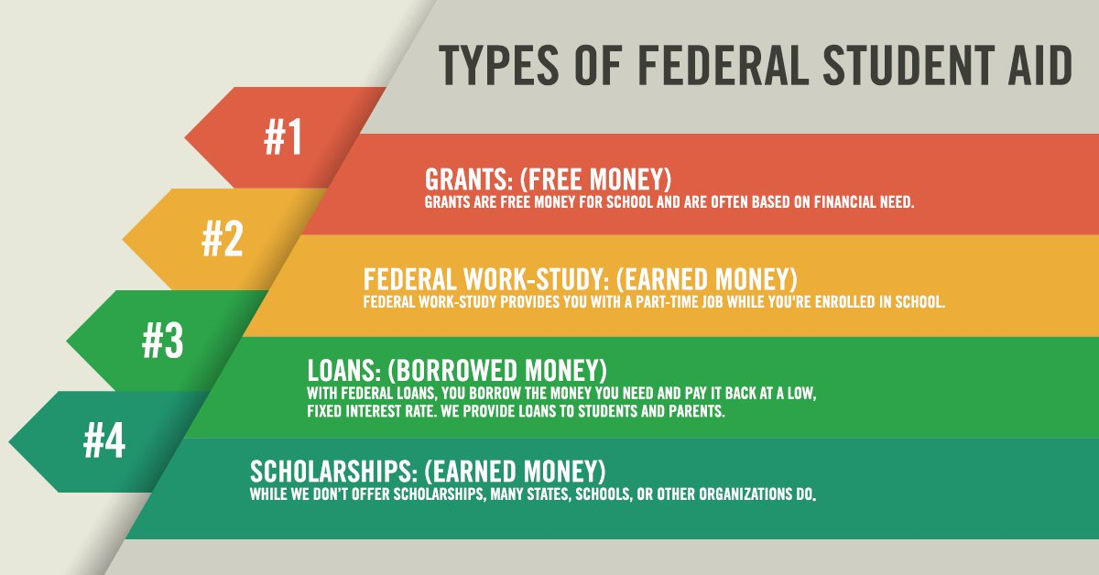
Advanced Placement (AP)
AP offers high school students the opportunity to take college-level courses while attending high school. All students are eligible to take AP courses but keep in mind that AP courses require significant study time outside of the school day. The AP testing period occurs in May. Testing fees will be announced. AP generally won’t count toward your intended college major. Ask if your college program accepts AP credit—some college programs require letter grades; not pass/fail. AP college credit is recorded as pass/fail credit on your college transcript. For more information about the national AP program, visit www.collegeboard.com.
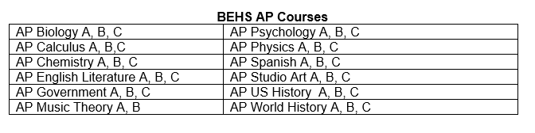

Concurrent Enrollment (CE)
Concurrent Enrollment (CE) means students are enrolled in high school and college courses at the same time. CE courses are offered at all Granite School District high schools and at the GTI. Most of Granite School District CE courses are SLCC approved.

BEHS Concurrent Enrollment | University Semester Credits | USU/Credit Requirement
USU AV 1100 Aviation Profession | 1 | USU Elective Credit BEHS
USU AV 2300 Private Ground School | 4 | USU Elective Credit BEHS
USU BCIS 1300 Website Design | 3 | USU Elective Credit USU BC
USU BIOL 1010 Biology and the Citizen | 3 | Breath Life Science BEHS
USU 1320 Civilization: Humanities | 3 | Breadth Humanities USU BC
USU ENGR. 1000 Intro to Engineering | 3 | USU Elective USU BC
USU ENGLISH 1010 Intro to Writing | 3 | Communications Literacy Credit BEHS
USU FCSE 1140 Sports and Outdoor Product Design | 2 | USU Elective Credit BEHS
USU GEOG. 1010 Intro to Geology | 3 | Breadth Physical Science USU BC
USU HDFS 1500 Human Development | 3 | Breadth Social Science BEHS
USU HIST 1700 American Civilizations | 3 | Breadth American Institution USU BC
USU MATH 1050 College Algebra | 4 | Quantitative Literacy Credit BEHS
USU MUSIC 1010 Intro to Music | 3 | Breadth Creative Arts BEHS
USU POLSC 1100 US Gov. & Politics | 3 | Breadth American Inst. USU BC
USU PSYC 1010 General Psychology | 3 | Breadth Social Science USU BC
USU STATS 1040 Intro to Statistics | 3 | Breadth Quantitative BEHS
USU TEAL 1010 Intro. to Education | 3 | USU Elective USU BC
USU THEA 1013 Understanding Theatre | 3 | Breadth Creative Arts BEHS
WSU AT 2175 Intro. to Sports Medicine | 3 | WSU Elective Credit BEHS
WSU HTHS 1110/1111 Integrated Human Anatomy and Physiology I | 8 | Elective
WSU MET 1000 Principles of Engineering A | 3 WSU (.5 BEHS) | WSU Elective Credit BEHS
WSU MFET 1000 Principles of Engineering B | 3 WSU (.5 BEHS) | WSU Elective Credit BEHS

Box Elder Middle/High School

Student Name: __________________________ Parent/Guardian Name: _______________________________
Career Interest(s): ________________________________________________________________________________
Career Technology Pathway(s): ___________________________________________________________________________

◻ On the Job Training ◻ Technology/College ◻ College/University

9th Grade (Freshman)
Language Arts 9A | Language Arts 9B | Language Arts 9C
Secondary Math 1A | Secondary Math 1B | Secondary Math 1C
Earth Systems A | Earth Systems B | Digital Studies
Geography
Participation Skills/PE
10th Grade (Sophomore)
Language Arts 10A | Language Arts 10B
Secondary Math 2 A | Secondary Math 2 B
Biology A | Biology B
World Civilizations | Health II
Fit for Life or Swim for Life
Social Studies Elective
11th Grade (Junior)
Language Arts 11A | Language Arts 11B
Math A or Science A | Math B or Science B
US History A | US History B
Additional PE
12th Grade (Senior)
Language 12A | Language 12B
Math A or Science A | Math B or Science B
US Government | Financial Literacy

30 credits and passing the basic civics test are required for graduation Notes:
d
Subject | Each box/class worth .5 credit.
English (4.5 Credits) | 9 | 9 | 9 | 10 | 10 |  | 11 |  | 11 |  | 12 |  | 12
Math (3.5 Credits)
Science (3 Credits)
Geography (.5)
World Civilizations (.5 Credits)
US History (1 Credit)
US Government (.5 Credit)
Social Studies Elective (.5 Credit)
Health Education II (.5 Credit)
Fit or Swim for Life (.5 Credit)
Participation Skills (.5 Credit)
Additional PE (.5 Credit)
Fine Arts (1.5 Credits)
Financial Literacy (.5 Credit)
Digital Studies (.5 Credit)
Career & Technical Ed. CTE (1 Credit)
Electives (10.5 Credits)

Student Signature Parent/Guardian Signature Counselor/Advisor Sig. & Date
8th _______________________ __________________________ __________________________
9th_______________________ __________________________ __________________________

For more information about courses offered at BEHS, please go to the following websites:

goo.gl/NrVqf7

goo.gl/36S9QM

College-Bound Student Athletes

NCAA Eligibility

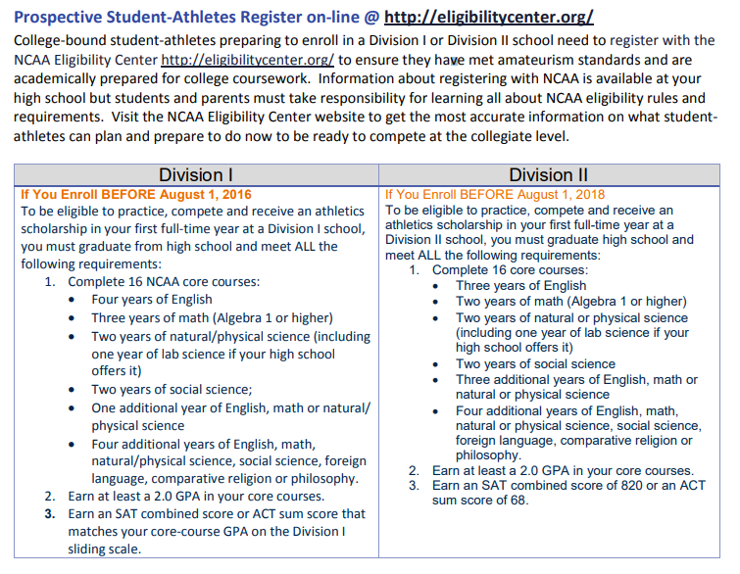
ACT
The ACT is an entrance exam used by most colleges and universities to make admissions decisions. It is a multiple-choice, pencil-and-paper test administered by ACT.
The purpose of the ACT test is to measure a high school student's readiness for college and provide colleges with one common data point that can be used to compare all applicants. College admissions officers will review standardized test scores alongside your high school GPA, the classes you took in high school, letters of recommendation from teachers or mentors, extracurricular activities, admissions interviews, and personal essays. How important ACT scores are in the college application process varies from school to school.

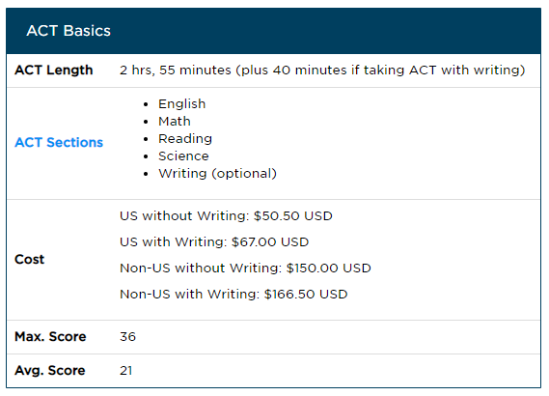
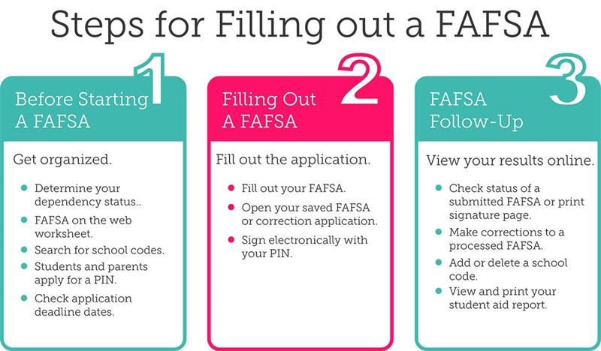

Regents’ Scholarship

Regents’ Scholarship is awarded to students for taking academically rigorous courses in high school. It is designed to encourage Utah high school students to prepare for college academically and financially by taking a core course of study and saving for college. The scholarship may be used at any public college or university in the Utah System of Higher Education. Learn more at https://stepuputah.com/program/regents-scholarship/.

- Take the required courses:
  - 4 credits of English
  - 4 credits of Math (at least 1 credit must be selected from an advanced course)
  - 3 credits of a Social Science
  - 3 credits of a lab-based science
  - 2 credits of the same world language (other than English)
- Earn at least a 3.3 cumulative high school GPA.
- Earn at least a score of 22 on the ACT.
- Meet college enrollment requirements.
- Fill out the FAFSA
- Graduate from a Utah high school
- Be a U.S. citizen

You will apply for the Regents' Scholarship during your senior year. The application opens mid-November and is due no later than February 1. A priority deadline may be established each year. Additional details about the application process will be available on RegentsScholarship.org.

Regents can change from year to year. Please check the website frequently to make sure you’re meeting the requirements.

Contact Info
regentsscholarship@ushe.edu
801-321-7159
Regents Scholarship Program
PO Box 145114
Salt Lake City, UT 84114-5114

Middle School Scholarships

Kohl's Kids Who Care Program
Each year, Kohl’s provides several prizes and scholarships to students (ages 6 through 18) who have volunteered within the past year. One winner at each store receives a $50 gift card and advances to the regional level, where he/she competes for a $1,000 scholarship. Ten regional winners will be selected to receive an additional $10,000 national award. Deadline: March 15.

Nicholas A. Virgilio Memorial Haiku Competition
Students in grades 7 through 12 may compete in this creative writing contest. Students may submit up to three haikus, as long as the work has not been previously published or submitted in any other contest. Six winners will each receive $50. Deadline: March 25.

“I Want to Go to College” Writing Contest
This contest is open to Nebraska seventh and eighth graders. Winners will receive a contribution to their state-sponsored 529 college savings plan, ranging between $500 and $2,000 each. Deadline: March 28.

Doodle4Google
Any student in elementary, middle, or high school may submit their artwork for consideration. Students simply need to take the Google name and turn it into something creative that reflects this year’s theme. National finalists will each receive a $5,000 scholarship. The Grand Prize winner will receive a $30,000 scholarship and his/her school will also receive a $50,000 technology grant. Deadline: March (TBA).

The Gloria Barron Prize for Young Heroes
Each year, the Barron Prize honors 25 outstanding students between the ages of 8 and 18. Students are recognized for their contributions to their community and the environment. The top 10 students will each receive a $5,000 scholarship. Deadline: April 15.

The Healers Trilogy Contest
Students in grades 6 through 12 may submit a billboard, video, speech, essay, poem, song, or commercial based on Donna Labermeier’s book, The Healers, which is free to contestants. There are six scholarships, ranging in value from $500 to $2,500 each. Deadline: May 16.

Courage in Student Journalism Awards
Middle school and high school students who have exercised their First Amendment rights, despite difficulty or resistance, may be eligible to win a $5,000 scholarship through this contest sponsored by the Student Press Law Center, the Center for Scholastic Journalism at Kent State University, and the National Scholastic Press Association. Deadline: June 8.

Patriot’s Pen Writing Contest
This program, sponsored by the Veterans of Foreign Wars (VFW), is open to students in grades 6 through 8. Students must submit an essay addressing this year’s topic, ‘Why I Appreciate America’s Veterans.” Prizes are given to the top 40 students, ranging between $500 and $5,000each. Deadline: Nov. 1.

Jif™ Most Creative Sandwich Contest
Each fall, Jif™ sponsors a cooking contest for children between the ages of 6 and 12. Students must creative a main dish, side item, appetizer, or dessert using peanut butter as one of the ingredients. The contest typically opens in late August, so students can start working on their recipes now. One lucky winner will receive a $25,000 scholarship and four runners-up will each receive $4,000 for college. Deadline: November (TBA).

Angela Award
Female students in grades 5 through 8, who have an interest in science, may apply for this program. One winner will receive a $1,000 savings bond. Deadline: Nov. 30.

Scholastic Art & Writing Awards
Each September, students in grades 7 through 12 can compete in 28 different categories, including, but not limited to: comic art, fashion, painting, photography, poetry, short story, journalism, and video games. More than $250,000 in scholarships is awarded annually.

College and Career Readiness Indicators

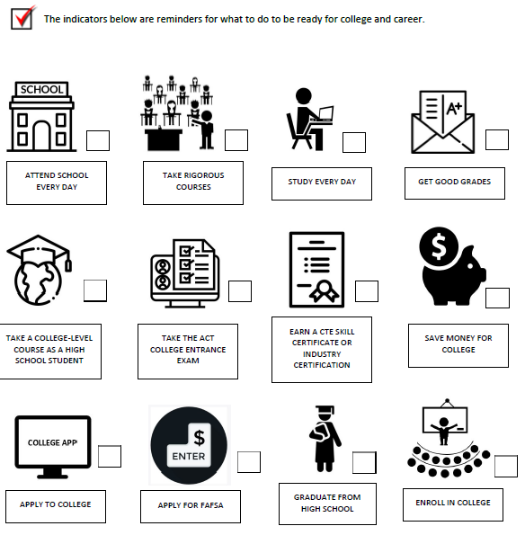

What Will I Do?

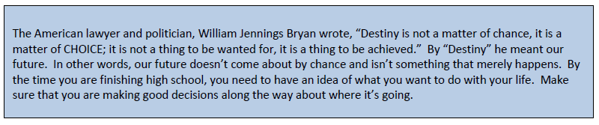

What is your plan?

___________________________________________________________________________________________

___________________________________________________________________________________________

___________________________________________________________________________________________

___________________________________________________________________________________________

___________________________________________________________________________________________

Box Elder County Volunteer Opportunities

ANIMAL SHELTER
1220 West Forest St.
Vickie 723-1231
- Clean Cages, feed and bath animals

BEAR RIVER MIGRATORY BIRD REFUGE
2155 West Forest St. 435-734-6438
Volunteer Coordinator: Kathy Stoffer
- Assist with staffing visitor information desk and bookstore.
- Help with education programs, landscaping, providing bird refuge tours & more

BRIGHAM CITY CORPORATON
Community/Senior Center 24 N 300 W.
Coordinator: Tammy Hadlie 435-226-1454
- Cemetery—Pick up pinecones
- Finance: collating, sorting/opening mail, stuffing envelopes
- Public works—sorting/updating records, clerical, airport cleanup, “adopt street”
- Police—neighborhood watch, computer input, photo copy tickets, transcribe
- Parks & Recreation—park cleanup, coaching/officiating, graffiti patrol
- Police dept.—youth court
- Jr. Parade Peach Days
- Pumpkin Painting for Nursing Homes
- Peach Days
- Country Fair Booth

BRIGHAM CITY TRAIN DEPOT
850 West Forest St.
Nancy Cannon 435-723-3963
- Assist with programs, activities & yard word

CENTRO DE LA FAMILIA
6980 North 22500 West, Honeyville
Benjamin Wynn 435-239-7700
- Office assistance, Teachers’ Assistant, Grounds Maintenance

COMMUNITY FOOD
272 North 200 West
Joleen Groberg 435-723-1449
- Food Collections, sort commodities

FAMILY SUPPORT CENTER
276 North 200 East
Marie Escobedo 435-723-6010
- Childcare, yard work, clerical, cleaning

FINE ARTS CENTER
58 South 100 West
Susan Neidert 435-723-0740
- Assist refurbishing building, provide puppet shows, assist with programs

HERITAGE THEATER
2505 Hwy 89, Perry, Utah
Julie Coleman 435-723-5603
- Assist with maintenance, yard work

LIBRARY
26 East Forest
Sue Hill 435-723-5850
- Literacy Tutoring schools/Lincoln Center, ESL tutoring, binding books

LINCOLN CENTER
271 North 100 West
JueneElle Jeffries 435-723-6224
- Boys and Girls Club, Soup Kitchen, Independent Living Program, Yard Work

TREEHOUSE CHILDREN’S MUSEUM
347 22nd St. Ogden
Gwen Skeen 435-394-7663
- Work in exhibit area, art garden, gift shop, toddler time

WILLARD BAY
Jeff Steele 435-734-9494
- Plant trees, clean areas, help with building projects

Pathways & Career and Technical Education (CTE)

CTE classes provide specific skills training. Students can take CTE courses at their high school, at other high schools, and at the Bridgerland Technical College (BTC) (https://btech.edu/).

BTC offers pathways that can lead a student to a career upon graduation from high school and even an associate’s degree from Utah State University. These programs are free to high school students (except for certain fees associated with equipment or materials necessary for the program). Students may choose to attend all day or half a day (a.m. or p.m. session).

BTC Pathways are also available during the summer. BESD will cover tuition costs. Students can register for summer Btech by taking their student body card to the Btech Campus or BBCC Campus (if applies) in May. Contact Heather Murphy, Logan Campus, at 435-750-3189 for summer school information and registration. BTC does not award high school or college credit; they report hours of completed instruction and competencies. BTC awards Industry Certifications. BEHS will award .5 high school credits for 60 hours of BTC instruction.

Please see the following website for more specific information about each Pathway offered at Btech: https://btech.edu/students/pathways/
bit.ly/2VvqTkp

Agricultural Mechanics Systems  Required Courses  - Ag Systems Tech I A (.5)  - Ag Systems Tech I B (.5)  - Ag Systems Tech II A (.5)  - Ag Systems Tech II B (.5)  Elective Courses (1.0 credit)  - Ag Science A&B (BEMS) (1.0)  - Biology Ag A & B (1.0)  - Business Communication 1A (.5)  - Business Communication 1B (.5)  - Welding Tech, Entry (.5)  - Welding Tech Intermediate A (.5)  - Welding Tech Intermediate B (.5)  - Workplace Skills/CTE Internship (1.0)  Animal & Veterinary Science  Required Courses  - Animal Science 1A (.5)  - Animal Science 1B (.5)  - Vet Assistant 1A (.5)  - Vet Assistant 1B (.5)  Elective Courses (1.0 credit)  - Biology Ag A (.5)  - Biology Ag B (.5)  - Business Communication 1A (.5)  - Business Communication 1B (.5)  - Equine Science A (.5)  - BTECH Vet Assistant (1.0)  Workplace Skills/CTE Internship (1.0) |  | Agricultural Production Systems  Required Courses  - Animal Science 1 A (.5)  - Animal Science 1 B (.5)  - Plant & Soil Science A  - Plant & Soil Science B  Elective Courses (1.0 credit)  - Ag Science 1A (BEMS) (.5)  - Ag Science 1B (BEMS) (.5)  - Biology Ag A (.5)  - Biology Ag B (.5)  - Business Communication 1A (.5)  - Business Communication 1B (.5)  - Workplace Skills/CTE Internship (1.0)  Plant Science  Required Courses  - Floriculture (.5)  - Plant & Soil Science A (.5)  - Plant & Soil Science B (.5)  Elective Courses (1.5 credits)  - Ag Science 1A (BEMS) (.5)  - Ag Science 1B (BEMS) (.5)  - Biology Ag A (.5)  - Biology Ag B (.5)  - Business Communication 1A (.5)  - Business Communication 1B (.5)  - Workplace Skills/CTE Internship (1.0) |  |  |  |  | CAD Architectural Design  **All 3.0 credits may be completed at BTECH  Required Courses  - BBCC/BTECH Drafting (1.5)  Elective Courses (1.5 credits)  - Physics with Tech A (.5)  - Physics with Tech B (.5)  - Workplace Skills/CTE Internship (1.0)  Carpentry  **All 3.0 credits may be completed at BTECH  Required Courses  - BTECH Building Technology (2.0)  Elective Courses (1.0 credit)  - BBCC/BTECH Drafting (1.0)  - Workplace Skills/CTE Internship (1.0) |  |  |  |  | Office/Admin Support  Required Courses  - Business Communication 1A (.5)  - Business Communication 1B (.5)  - Business Office Specialist (.5)  Elective Courses (1.5 credits)  - Accounting 1A (.5)  - Accounting 1B (.5)  - Exploring Business & Marketing (.5)  - Digital Graphics Arts, Intro (.5)  - Digital Media 1 (.5)  - Web Development 1A (.5)  - Web Development 1B (.5)  - Workplace Skills/Internship (1.0)  Fashion, Apparel  & Textiles  Required Courses  - Fashion Design Studio (.5)  - Designer Sewing 1 (.5)  - Designer Sewing 2 (.5)  - USU FSCE 1140 – Sports & Outdoor Product Design OR Sports Sewing (.5)  Elective Courses (1.0 credit)  - Accounting 1A (.5)  - Accounting 1B (.5)  - BTECH Fashion Merch. (1.0)  - Workplace Skills/CTE Internship (1.0)
Interior Design  Required Courses  - Interior Design 1 (.5)  - Interior Design 2 (.5)  Elective Courses (2.0 credits)  - BTECH Interior Design (1.0)  - Designer Sewing 1 (.5)  Workplace Skills/CTE Internship (1.0)  Outdoor Product Development & Design  Required Courses  - Designer Sewing 1 (.5)  - Designer Sewing 2 (.5)  - USU FSCE 1140 – Sports & Outdoor Product Design OR Sports Sewing (.5)  Elective Courses (1.0 credit)  - Digital Graphics Arts, Intro (.5)  - Digital Media 1 (.5)  - BBCC/BTECH Drafting (1.0)  - Workplace Skills/CTE Internship (1.0) |  |  | Commercial Photography  Required Courses  - Commercial Photo 1 (.5)  - Commercial Photo 2 (.5)  Elective Courses (1.5 credits)  - Commercial Photo 3 (.5)  - Commercial Photo 4 (.5)  - Commercial Art 1 (.5)  - Commercial Art 2 (.5)  - Digital Graphics Arts, Intro (.5)  - Digital Media 1 (.5)  Workplace Skills/CTE Intern (1.0)  Digital Media  Required Courses  - Digital Graphics Arts, Intro (.5)  - Digital Media 1 (.5)  - 3D Graphics (.5)  - 3D Animation (.5)  Elective Courses (1.0 credit)  - Digital Media 2A (.5)  - Digital Media 2B (.5)  - BBCC/BTECH Intro to Information Tech (1.0)  - IT Academy (BTECH Broadcast) (1.0)  - Web Development (.5)  - Workplace Skills/CTE Internship (1.0) |  |  | Mechanical Engineering  Required Courses  - Intro to Engineering A (.5)  - Intro to Engineering B (.5)  - Principles of Eng. A & B (1.0) OR  - WSU Met 1000/1150 Principles of Engineering (1.0)  Elective Courses (1.0 credit)  - Engineering Design & Dev (1.0)  - Physics with Technology A (.5)  - Physics with Technology B (.5)  - AP Physics (1.0)  - Workplace Skills/CTE Internship (1.0)  Robotics  **All 3.0 credits may be completed at BTECH  Required Courses  - BTECH -Automated Mfg & Robotics (AM STEM) (1.0)  Elective Courses (2.0 credits)  - Computer Programming 1A (.5)  - Computer Programming 1B (.5)  - BTECH Electronics (1.0)  - Physics with Technology A (.5)  - Physics with Technology B (.5)  - AP Physics (1.0)  Workplace Skills/CTE Internship 1.0) |  |  |  |  | CAD Mechanical Design  Required Courses  - Intro to Engineering A (.5)  - Intro to Engineering B (.5)  - BBCC/BTECH Drafting (1.0)  Elective Courses (.5 credit)  - Physics with Technology A (.5)  - Physics with Technology B (.5)  - AP Physics (1.0)  Workplace Skills/CTE Internship (1.0)  Manufacturing Engineering  Required Courses  - Computer Integrated Mfg. A (.5)  - Computer Integrated Mfg. B (.5)  Elective Courses (2.0 credits)  - BTECH Machine Tool (1.0)  - Physics with Technology A (.5)  - Physics with Technology B (.5)  - AP Physics (1.0)  - Welding, Entry (.5)  - Workplace Skills/CTE Internship (1.0)
Dental Assistant  **All 3.0 credits may be completed at BTECH  Required Courses  - BBCC/BTECH – Dental Assist (2.0)  Elective Courses (1.0 credit)  - Food & Nutrition 1 (.5)  - Food & Nutrition 2 (.5)  - Health Science Intro (.5)  - Med Anatomy & Physiology A (.5)  - Med Anatomy & Physiology B (.5)  - Medical Terminology (also at BBCC/BTECH) (.5)  - WSU Advanced Anatomy A (.5)  - WSU Advanced Anatomy B (.5)  - WSU Advanced Anatomy C (.5)  Workplace Skills/CTE Internship (1.0)  Medical Assistant  **All 3.0 credits may be completed at BTECH  Required Courses  - BTECH Medical Assistant (1.0)  Elective Courses (2.0 credits)  - Health Science Intro (.5)  - Med Anatomy & Physiology A (.5)  - Med Anatomy & Physiology A (.5)  - Medical Terminology (also at BBCC/BTECH) (.5)  - WSU Advanced Anatomy A (.5)  - WSU Advanced Anatomy B (.5)  - WSU Advanced Anatomy C (.5)  Workplace Skills/CTE Internship (1.0) |  |  | Nursing Services  Required Courses  - BBCC/BTECH Nurse Assistant (1.0)  Elective Courses (2.0 credits)  - Food & Nutrition 1 (.5)  - Food & Nutrition 2 (.5)  - Health Science Intro (.5)  - USU HDFS 1500/Human Dev. (1.0)  - Med. Anatomy & Physiology A (.5)  - Med. Anatomy & Physiology B (.5)  - Medical Terminology (.5) (also at BBCC/BTECH)  - WSU Advanced Anatomy A (.5)  - WSU Advanced Anatomy B (.5)  - WSU Advanced Anatomy C (.5)  Workplace Skills/CTE Internship (1.0)  Pharmacy Tech  **All 3.0 credits may be completed at BTECH  Required Courses  - BTECH – Pharmacy Tech (1.0)  Elective Courses (2.0 credits)  - Health Science Intro (.5)  - Med Anatomy & Physiology A (.5)  - Med Anatomy & Physiology B (.5)  - Medical Terminology (.5) (also at BBCC/BTECH  - WSU Advanced Anatomy A (.5)  - WSU Advanced Anatomy B (.5)  - WSU Advanced Anatomy C (.5)  - Workplace Skills/CTE Internship (1.0) |  |  | Hospitality & Tourism  Required Courses  - Hospitality & Tourism (.5)  - Sports & Entertainment Mktg. (.5)  Elective Courses (2.0 credits)  - Accounting 1A (.5)  - Accounting 1B (.5)  - Business Communication 1A (.5)  - Business Communication 1B (.5)  Workplace Skills/CTE Intern (1.0)  Culinary Arts  **All 3.0 credits may be completed at BTECH  Required Courses  - Culinary Arts (1.0)  - Food & Nutrition 2 (.5)  Elective Courses (1.5 credits)  - Food & Nutrition 1 (.5)  - BTECH Culinary Arts (1.0)  - Hospitality & Tourism (.5)  Workplace Skills/CTE Intern (1.0) |  |  | Cosmetology  **All 3.0 credits may be completed at BTECH  Required Courses  - BBCC – Cosmetology/Barbering (2.0) *  Elective Courses (1.0 credit)  - Accounting 1A (.5)  - Accounting 1B (.5)  Workplace Skills/CTE Intern (1.0)  Accounting & Financial Operations  Required Courses  - Accounting 1A (.5)  - Accounting 1B (.5)  Elective Courses (2.0 credits)  - Business Communication 1A (.5)  - Business Communication 1B (.5)  - Business Law (.5)  - Business Office Specialist (.5)  - Exploring Business & Mktg (.5)  - Workplace Skills/Internship (1.0)
Programming & Software Development  Required Courses  - Computer Science Principles A (.5)  - Computer Science Principles B (.5)  - Computer Programming 1A (.5)  - Computer Programming 1B (.5)  Elective Courses (1.0 credit)  - Exploring Computer Science 1 (.5)  - Exploring Computer Science 2 (.5)  - BBCC/BTECH Intro to Information Tech (1.0)  - IT Academy (BTECH Broadcast) (1.0)  - BTECH Web & Mobile Dev (1.0)  - Workplace Skills/CTE Internship (1.0)  Web Development  **All 3.0 credits may be completed at BTECH  Required Courses  - Web Development 1A (.5)  - Web Development 1B (.5)  - BTECH -Web & Mobile Dev (1.0)  Elective Courses (1.0 credit)  - BTECH Web & Mobile Dev. (continue in program for 1.0 additional credit)  - IT Academy (BTECH Broadcast) (1.0)  - Workplace Skills/CTE Internship (1.0) |  |  | Machine Tool  **All 3.0 credits may be completed at BTECH  Required Courses  - BTECH Machine Tool (1.0)  Elective Courses (2.0 credits)  - BBCC/BTECH Drafting (.5)  - Computer Integrated Mfg. A (.5)  - Computer Integrated Mfg. B (.5)  - Engineering Design & Dev (1.0)  - Welding Tech, Entry (.5)  - Welding Tech, Intermediate A (.5)  - Workplace Skills/CTE Internship (1.0)  Welding  Required Courses  - Welding Tech, Entry (.5)  - Welding Tech, Intermediate A (.5)  - Welding Tech, Intermediate B (.5)  Elective Courses (1.5 credits)  - Computer Integrated Mfg. A (.5)  - Computer Integrated Mfg. B (.5)  - Engineering Design & Dev. (1.0)  - BBCC/BTECH Drafting (1.0)  - BTECH Machine Tool (1.0)  - BTECH Welding Tech (1.0)  Workplace Skills/CTE Internship (1.0) |  |  | Aviation  Required Courses  - USU AV 1100 – The Aviation Profession (.5)  - USU AV 2330 – Private Ground School (.5)  Elective Courses (2.0 credits)  - BTECH Electronics (1.0)  - Workplace Skills/CTE Internship (1.0)  Automotive: Collision Repair  **All 3.0 credits may be completed at BTECH  Required Courses  - BTECH – Auto Collision (1.0)  Elective Courses (2.0 credits)  - Accounting 1A (.5)  - Accounting 1B (.5)  - Ag Systems Tech 1A (.5)  - Auto Tech 1 (.5)  - Auto Tech 2 (.5)  - Welding Tech, Entry (.5)  - Welding Tech, Intermediate A (.5)  Workplace Skills/CTE Internship (1.0) |  |  |  |  |  |  | Automotive: Service Technician  Required Courses  - Auto Tech 1 (.5)  - Auto Tech 2 (.5)  - Auto Tech 3 (can repeat up to 1.0 credit)  Elective Courses (1.0-1.5 credits)  - Accounting 1A (.5)  - Accounting 1B (.5)  - BTECH Auto Collision Repair (1.0)  - Ag Systems Tech 1A (.5)  - Welding Tech, Entry (.5)  - Welding Tech, Intermediate A (.5)  - Workplace Skills/CTE Internship (1.0)  Diesel  **All 3.0 credits may be completed at BTECH  Required Courses  - BTECH – Diesel (1.0)  Elective Courses (2.0 credits)  - Accounting 1A (.5)  - Accounting 1B (.5)  - Auto Tech 1 (.5)  - Auto Tech 2 (.5)  - Auto Tech 3 (.5)  - Workplace Skills/CTE Internship (1.0)

